100 Not-Boring Writing Prompts for Middle- and High Schoolers

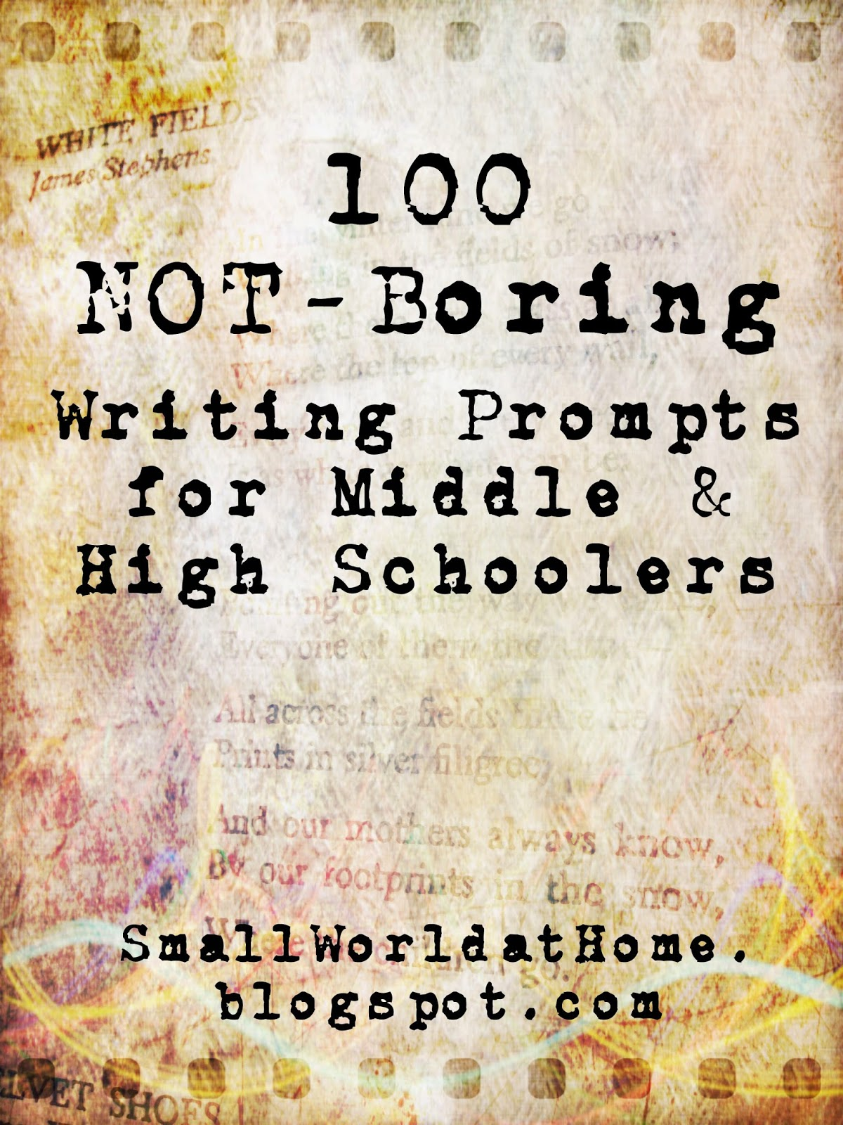
1. Attach an image (photo, magazine, etc.) to a notebook page and write about it.
2. What things will people in the future say about how we live now? (Examples: They ate that? They believed that?)
3. Pick one from each list to make a creature and animal combination. Now write a short story or scene in which this creature appears.
List 1 List 2
Vampire porcupine
Ninja armadillo
Zombie pig
Pirate goat
Mummy lobster
Clown possum
Banshee shark
Wraith moray eel
4. Imagine a future in which we each have a personalized robot servant. What would yours be like? What would it do? What features would it have?
5. What does your name mean? Free write about names: names you like, names you don’t, how a name can affect a person’s life, how you feel about your own name, why your parents chose your name, etc.
6. Create a brand new holiday with its own traditions, rituals, foods, and activities.
7. What road-trip would you take if you suddenly could? Write about it.
8. List six true sentences that begin with the words “I'll never forget…”
9. Imagine that we lost all electricity, water, and gas for a month without any time to prepare. Write about how your life would change and how you would survive.
10. Make your bucket list for the next 5 years, the next 10 years, and for life.
11. Tell this story: “Well, I thought it was going to be a regular summer doing all our regular things…”
12. List 10 places in the world that you would most like to visit, 10 places you’ve been, and 10 places you would never want to go.
13. Think about hospitality in your family. What’s it like to have guests in your house? Do you prefer to have friends to your house or to go to a friend’s house?
14. Pick a family member of two and write about his or her reputation in your family, or tell a family legend.
15. A guitar pick, a red balloon, and a wicker basket. Write a scene or a poem that includes these three objects.
16. What animal would judge us the most? Write a scene (based on truth or fiction) where two or more people are doing something silly, and they're being observed and criticized by animals.
17. Write about your own worst family vacation memory.
18. Write about your best family vacation memory.
19. Imagine that someone says to you, “Because that's how we've always done it!” Write this out as a scene. (Think: Who said it, what were the circumstances, how did you respond, etc.)
20. What do you think about when you can't sleep? Turn it into a piece of writing.
21. What traditions does your family have? List all of them or just pick one and write about it.
22. Think about your strongest emotion right now (irritation, boredom, happiness, contentment, etc.) and find five quotes about this emotion.
23. What do you struggle with the most? Write about it.

24. Write a self-portrait.

25. What can we learn from contrast? Write a description of something very dark (like a crow) in a very light place (like a field of snow). Make the dark thing seem innocent and the light thing seem ominous.

26. Write about someone who has no enemies. Is it even possible?

27. Think of a person from your past who really deserved a good scolding but never got one. Write a fictional piece where you tell that person off intelligently.

28. Can honesty honestly be bad? Write about someone, fact or fiction, who gets in trouble for being too truthful.

29. The word “fat” carries a negative connotation. Write a story or observation where something fat is celebrated.

30. What animal lives beneath your human skin? A mouse? A cougar? Or what? Explain with writing.

31. Write about the best piece of advice you ever received.

32. Remember a favorite book from your childhood. Write a scene that includes you and an old copy of that book you find somewhere.
-->
33. “I was so mortified, I wanted to crawl in a hole!” Write a short narrative (fiction or nonfiction) where this is your first sentence. Illustrate it if you want.
34. Should books ever be banned? Discuss. If no, explain why. You might want to look at a least of commonly banned books. If yes, explain under what circumstances.
35. Ernest Hemingway said to “write hard and clear about what hurts.” Write about something that hurts, whether it’s an emotional, physical, or phantom pain.
36. What if everyone had to wear a shirt with his or her Myers-Briggs personality type on it? What would this change? How would this affect the way people interact with each other? Would you like this or hate it? (If you don’t know your “type,” try this site.
37. William Shakespeare wrote that: “Conversation should be pleasant without scurrility, witty without affectation, free without indecency, learned without conceitedness, novel without falsehood.” Write your thoughts about conversation, or make up dialogue between two characters who are meeting each other for the first time in an unexpected place.
38. Tell this story: “There it was, finally. Our island. Our very own island. It looked beautiful above the waves of fog, but there was still one question to be answered: why had they sold it to us for only five dollars?”
39. Maya Angelou said “I’ve learned that you can tell a lot about a person by the way s/he handles these three things: a rainy day, lost luggage, and tangled Christmas tree lights.” Tell a story in which a character has to deal with one, two, or all three of these scenarios. How does your character respond?

40. You have a chance to go back and completely re-do an event in your life. What is it, and how to you change it? What is the outcome? This can be a real or fictional event.
41. Pick two characters from different books you’ve read this year and have them get in an argument about something (e.g., who has suffered more, who has had a happier life, etc.).
42. The one shoe in the road: why is it there? Write a story about the circumstances that led to one shoe in the middle of the road.
43. You get to guest star on a TV show. What show is it? What happens in this particular episode?

44. What would you pack in your suitcase if you could not go home again?

45. You can only use 20 words for the rest of your life. You can repeat them as often as you wish, but you can only use these words. What are they?

46. What current fashion in clothing do you particularly like or dislike? Why?

47. Choose five symbols or objects that represent you. Why did you choose these things?

48. "When I stepped outside, the whole world smelled like…" Write a scene that starts with that line.

49. Write a poem entitled "Hitchhiking on a Saturday Afternoon."

50. Use these two lines of dialogue in a story: "What's in your hand?" "It's mine. I found it."

51. Write a scene that happens in a parking lot between a teenager and a man in a convertible.

52. If you only had one window to look out of for the next six months, what would you want to see on the other side? Describe the view. How would it change?

53. Write a story for children. Start with “Once upon a time” or “Long ago in a land far away.” Include a dragon, a deadly flower, and a mask.

54. "Did she actually just say that?" Write a scene that includes this line.

55. “Call it a clan, call it a network, call it a tribe, call it a family. Whatever you call it, whoever you are, you need one.” — Jane Howard. Write what comes to mind when you read this quote.

56. List five things you want in a relationship.

57. List ten favorite lines from movies.

58. Write about the biggest mistake you made this week. Now write about the best thing you did this week.

59. What is the very first memory that you have? Write about it.

60. What if your pet could only talk to you at midnight for an hour?

61. Write an acrostic poem using your full name and three words that describe you—good and bad— for each letter. For example,
S: sensitive, stubborn, smiling.
A: artistic, argumentative, agoraphobic
M: melodramatic, moody, magical
62. What if you could create your own TV show with all your friends and loved ones as the cast? What kind of show would it be and who would play which parts?

63. Take a photo or draw a picture of every place you go in a day. Put the pictures or drawings in your journal.

64. A to Z: Make an alphabetical list of advice for someone who is about to become a teenager. For example: A: ask forgiveness, not permission. B.: bake cookies. C.: cook something delicious once a month. D: don't compare yourself to others.

65. Find 10 quotes about happiness.

66. Write about 5 things you'd rather be doing right now.

67. Write out the lyrics to your favorite song. Find some pictures to illustrate the song.

68. Who do you spend the most time talking to? Siblings, parents, friends? Make a list of who you actually talk to during the day and estimate the amount of time invested in each individual. Does the list reveal your priorities? Is it proportional to what is important to you? Make notes of what you talk about in your daily conversations.

69. Find a quote for each month of the year.

70. Animals can sometimes seem remarkably human. Describe an
experience with an animal that acted in a very human way.
71. Imagine you opted to have yourself frozen for 50 years. Describe your first days unfrozen, 50 years in the future.
72. Imagine that you are an astronaut who has been doing research on the moon for three years. You are do to go back to earth in a week when nuclear war breaks out on earth. You watch the earth explode. Then what?
73. Create a menu from a fictitious restaurant. Make sure the restaurant has a theme, such as Classic Books, and the food should all be given appropriate names (e.g., “Mockingbird Pie”).
74. Preconceived notions are often false. Describe a time when you discovered that a preconceived notion of yours (about a person, place, or thing) turned out to be wrong.
75. Create a story using words of one-syllable only, beginning with a phrase such as:
“The last time I saw her, she...”
“From the back of the truck...”
“On the night of the full moon...”
“The one thing I know for sure…”
76. Describe a significant person (teacher, neighbor, mentor, coach, parent, sibling, sweetheart) with as many physical details as possible and as many similes as possible. (E.g., “Her hair was as golden as straw.”)
77. Write about your first name—why you were given it, what associations or stories are attached to it, what you think or know it means. Do the same for your last name. What name would you give yourself other than the one you actually have?
78. Parents are our first and most important teachers. Describe a valuable lesson you learned from one of your parents.
79. Imagine a moral dilemma (for example, you see someone shoplift or a friend tells a blatant lie to her parents about where she was last night) and explain what you would do and why you would do it.
80. Review an obituary, birth, or a section from the police record or classified ads section of a local newspaper. Choose one and tell the story behind it.
81. List the most attractive things about your current hometown. Now list the most unattractive things.
82. Come up with a list of nouns and a second list of verbs, all of one syllable each. Describe a scene or situation, using a minimum of ten words from each list.
83. Where is your happy place? Write about it and include a picture or drawing.
84. Create a how-to manual for something you can do well (make a craft, bake cookies, restring a guitar, apply make up, etc.). Describe the process so that someone else could complete the task based on your directions. Use present tense verbs.
85. Free write on this quote by Samuel Johnson: “Ignorance, when voluntary, is criminal.”
86. Find a favorite quote and work it into an illustration. (Inspiration here.)
87. Make a soundtrack for your life so far. List songs that describe you or different times of your life. (Make the actual soundtrack on Spotify, etc. too!)
88. Sometimes we find ourselves in situations that force us to face our deepest fears. Tell about a time when you had to face one of your greatest fears—or make up the story.
89. You’re a talk show host. Pick two guests. Why did you choose them? Are they people who get along, or people with vastly different viewpoints? Write about the episode.
90. What three books do you think should be required reading for everyone? Why?
91. “What you don’t know what hurt you.” Write a story that begins with this statement.
92. Free write on this quote by Woodrow Wilson: “Friendship is the only cement that will hold the world together.”
93. According to a Czechoslovakian proverb, “Better a lie that soothes than a truth that hurts.” Agree or disagree? Explain.
94. Rewrite “The Tale of the Three Little Pigs” by using people that you know as the pigs and the wolf.
95. There is a saying that you should be careful what you wish for, because you just might get it. Describe a time when you wished for something and got it—and then wished you hadn’t—or make up a story in which this happens to the character.
96. As the saying goes, “rules are meant to be broken.” Tell about a time when you broke the rules and what happened as a result.
97. "That's not what I meant!" Write a story that has this line in it somewhere.
98. A blue trash can, a red picture frame, a teddy bear with the stuffing falling out, and a padlock. Put these four items somewhere in a story, scene, or poem.
99. Write your name in outline letters on a whole sheet of paper. Now fill in each letter with words you like that begin with that letter. For example:
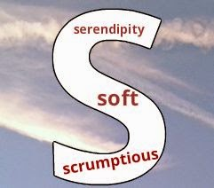
100. Make a word collage of who YOU are. Use pictures too, if desired.

